**LOGIC GATES**

**AIM:**

To realize the gates using universal gates.

**Theory:**

There are several basic logic gates used in performing operations in digital systems. The common ones are:

**1. AND Gate**:

- The AND gate performs logical multiplication of its inputs. It produces a high (logic 1) output only when all its inputs are high (logic 1). Otherwise, the output is low (logic 0).

**2.** **OR Gate**:

- The OR gate performs logical addition of its inputs. It produces a high output if any of its inputs is high.

**3.** **NOT Gate**:

- The NOT gate (also called an inverter) produces the complement of its input. If the input is high, the output is low, and vice versa.

These basic gates form the foundation for more complex logic circuits. They operate on binary signals (0s and 1s) and allow us to manipulate and process digital data.

Certainly! Let's explore the XOR and NAND gates:

**4. XOR Gate (Exclusive OR)**:

- The XOR gate produces a high output (1) if the number of true inputs is **odd**. If both inputs are the same (both true or both false), the output is low (0).

**5.** **NAND Gate (NOT-AND)**:

- The NAND gate produces a low output (0) only when **all** its inputs are true (1). Otherwise, the output is high (1).

Remember that both NAND and NOR gates are considered "universal gates," meaning any logical function can be constructed using them alone. If you replace the four NAND gates in an XOR gate with NOR gates, you get an XNOR gate, which can be converted to an XOR gate by inverting the output or one of the inputs.

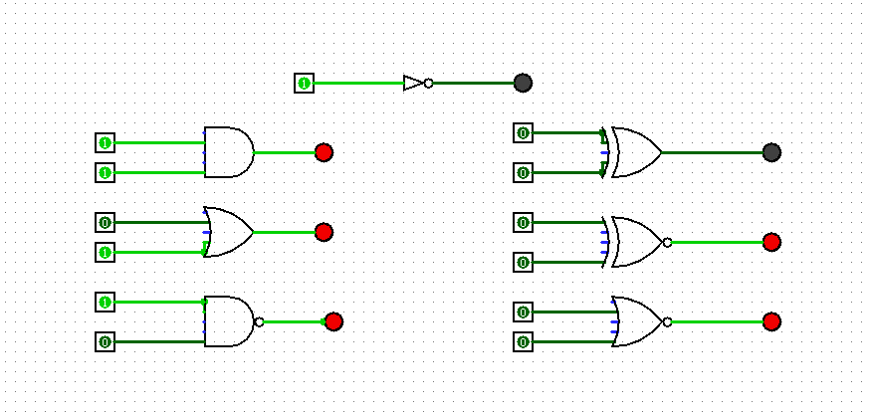

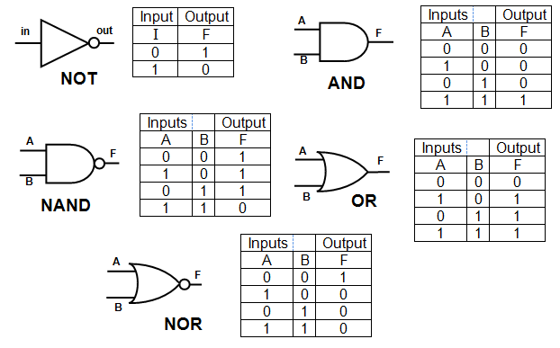

**Conclusion**:

Logic gates are fundamental building blocks in digital circuits. They allow us to manipulate binary signals (0s and 1s) to perform various logical operations. Here's a brief summary:

**1. AND Gate**: Produces a high output only when all inputs are high.

**2.** **OR Gate**: Produces a high output if any input is high.

**3.** **NOT Gate**: Inverts its input.

**4. XOR Gate (Exclusive OR)**: Outputs high if the number of true inputs is odd.

**5. NAND Gate (NOT-AND)**: Outputs low only when all inputs are true.

These gates form the foundation for more complex circuits, allowing us to design everything from simple adders to powerful processors.